CSA1304 - THEORY OF COMPUTATION
LABORATORY EXPERIMENTS

Name: R.Monish kumar
Reg No: 192372073

1. Write a C program to simulate a Deterministic Finite Automata (DFA) for the given language representing strings that start with a and end with a

Program Code
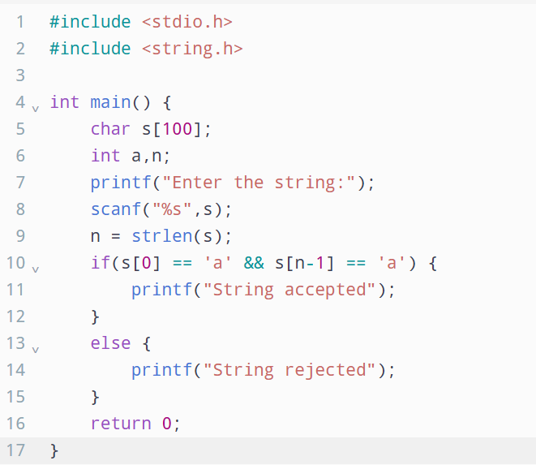

Output
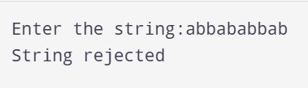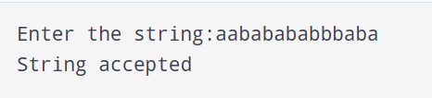

2. Write a C program to simulate a Deterministic Finite Automata (DFA) for the given language representing strings that start with 0 and end with 1

Program code
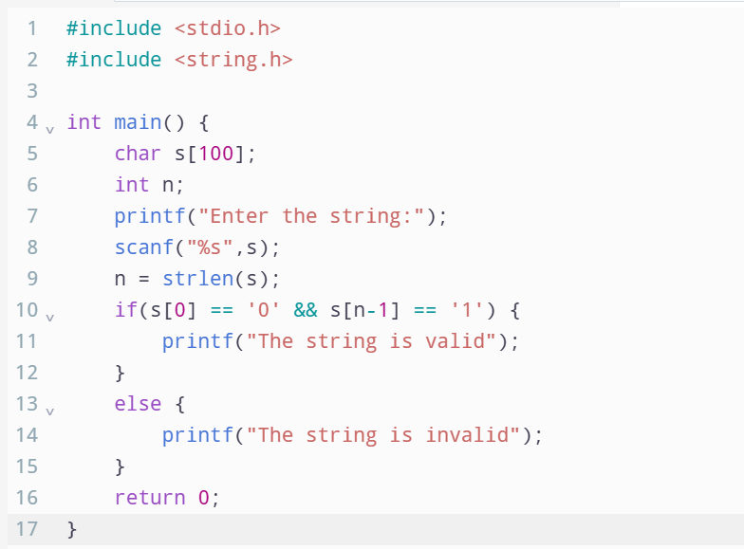

Output

